**TUGAS PRAKTIKUM**

**PRAKTIKUM PAW**

**MODUL 3 “Validation”**



|  |  |  |
| --- | --- | --- |
| **Disusun Oleh :** | | |
| Nama | : | Dewi Imani Al Qur’ Ani |
| Nim | : | 200411100014 |
| Kelas | : | PAW-B |
| **Dosen Pengampu :** | | |
| Nama | : | Ach. Khozaimi,S.Kom.,M.Kom. |
| Nip | : | 19860926 201404 1 001 |
| **Asisten Praktikum :** | | |
| Nama | : | M. Afifudin Abdullah |
| Nim | : | 190411100080 |

**PRODI TEKNIK INFORMATIKA**

**JURUSAN TEKNIK INFORMATIKA  
FAKULTAS TEKNIK**

**UNIVERSITAS TRUNOJOYO MADURA**

**2022**

1. Soal : Buatlah sebuah form yang berisi name, e-mail, website, comment, gender, tombol  submit, dan tampilan output dari inputan yang dimasukkan seperti berikut:

**Source Code:**

|  |
| --- |
| <!DOCTYPE html>  <html lang="en">  <head>    <meta charset="UTF-8">    <meta http-equiv="X-UA-Compatible" content="IE=edge">    <meta name="viewport" content="width=device-width, initial-scale=1.0">    <title>Prak3 Soal 1</title>  </head>  <body>  <?php    // membuat variabel error dan diset kosong    $nameErr = $emailErr = $genderErr = $websiteErr = "";    //membuat variabel untuk menampung inputan dari form    $name = $email = $gender = $comment = $website = "";    //membuat fungsi untuk validasi input form    function test_input($data) {     $data = trim($data);     $data = stripslashes($data);     $data = htmlspecialchars($data);     return $data;    }    ?>    <h2>Modul 3 - PAW 4B <br><?php echo "PHP Form Validasi";?><h3>    <h3>Nama : <?php echo "Dewi Imani Al Qur' Ani";?><br>Nim : 200411100014<h3>  <form method="post" action="<?php echo htmlspecialchars($_SERVER["PHP_SELF"]);?>">      <span class="error" style="color:red">* required field</span>      <br><br>      <label for="">Name: </label>      <input type="text" name="name">      <span class="error" style="color:red">* <?php echo $nameErr;?></span>      <br><br>      <label for="">E-mail: </label>      <input type="text" name="email">      <span class="error" style="color:red">* <?php echo $emailErr;?></span>      <br><br>      <label for="">Website: </label>      <input type="text" name="website">      <span class="error"><?php echo $websiteErr;?></span>      <br><br>      <label for="">Comment: </label>      <textarea name="comment" rows="5" cols="40"></textarea>      <br><br>      <label for="">Gender: </label>      <input type="radio" name="gender" value="female">Female      <input type="radio" name="gender" value="male">Male      <input type="radio" name="gender" value="other">Other      <span class="error" style="color:red">* <?php echo $genderErr;?></span>      <br><br>      <input type="submit" name="submit" value="Submit">  </form>  <?php    //menampilkan hasil dari inputan form    echo "<h1>Your Input:</h1>";    // echo $name;    // echo "<br>";    // echo $email;    // echo "<br>";    // echo $website;    // echo "<br>";    // echo $comment;    // echo "<br>";    // echo $gender;  ?>  </body>  </html> |

**Screenshoot:**

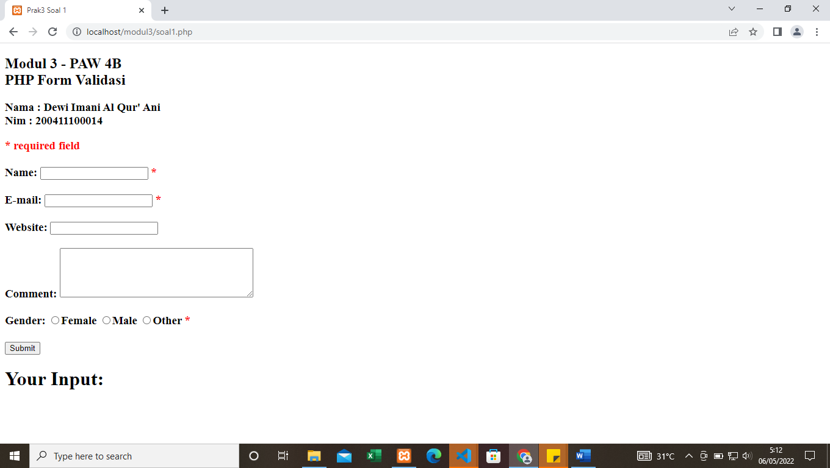

1. Soal : Buatlah validasi terhadap form, apabila form disubmit dalam keadaan kosong maka  akan muncul pesan seperti berikut:

**Source Code:**

|  |
| --- |
| <!DOCTYPE html>  <html lang="en">  <head>    <meta charset="UTF-8">    <meta http-equiv="X-UA-Compatible" content="IE=edge">    <meta name="viewport" content="width=device-width, initial-scale=1.0">    <title>Prak3 Soal2</title>  </head>  <body>  <?php    // membuat variabel error dan diset kosong    $nameErr = $emailErr = $genderErr = $websiteErr = "";    //membuat variabel untuk menampung inputan dari form    $name = $email = $gender = $comment = $website = "";    if ($_SERVER["REQUEST_METHOD"] == "POST") {    if (empty($_POST["name"])) {     $nameErr = "Name is required";    } else {     $name = test_input($_POST["name"]);    }    if (empty($_POST["email"])) {     $emailErr = "Email is required";    } else {     $email = test_input($_POST["email"]);    }    if (empty($_POST["website"])) {     $website = "";    } else {     $website = test_input($_POST["website"]);    }    if (empty($_POST["comment"])) {     $comment = "";    } else {     $comment = test_input($_POST["comment"]);    }    if (empty($_POST["gender"])) {     $genderErr = "Gender is required";    } else {     $gender = test_input($_POST["gender"]);    }    }    //membuat fungsi untuk validasi input form    function test_input($data) {     $data = trim($data);     $data = stripslashes($data);     $data = htmlspecialchars($data);     return $data;    }    ?>  <h2>Modul 3 - PAW 4B <br><?php echo "PHP Form Validasi";?><h3>  <h3>Nama : <?php echo "Dewi Imani Al Qur' Ani";?><br>Nim : 200411100014<h3>  <form method="post" action="<?php echo htmlspecialchars($_SERVER["PHP_SELF"]);?>">      <span class="error" style="color:red">* required field</span>      <br><br>      <label for="">Name: </label>      <input type="text" name="name">      <span class="error" style="color:red">* <?php echo $nameErr;?></span>      <br><br>      <label for="">E-mail: </label>      <input type="text" name="email">      <span class="error" style="color:red">* <?php echo $emailErr;?></span>      <br><br>      <label for="">Website: </label>      <input type="text" name="website">      <span class="error"><?php echo $websiteErr;?></span>      <br><br>      <label for="">Comment: </label>      <textarea name="comment" rows="5" cols="40"></textarea>      <br><br>      <label for="">Gender: </label>      <input type="radio" name="gender" value="female">Female      <input type="radio" name="gender" value="male">Male      <input type="radio" name="gender" value="other">Other      <span class="error" style="color:red">* <?php echo $genderErr;?></span>      <br><br>      <input type="submit" name="submit" value="Submit">  </form>  <?php    //menampilkan hasil dari inputan form    echo "<h1>Your Input:</h1>";    // echo $name;    // echo "<br>";    // echo $email;    // echo "<br>";    // echo $website;    // echo "<br>";    // echo $comment;    // echo "<br>";    // echo $gender;  ?>  </body>  </html> |

**Screenshoot:**

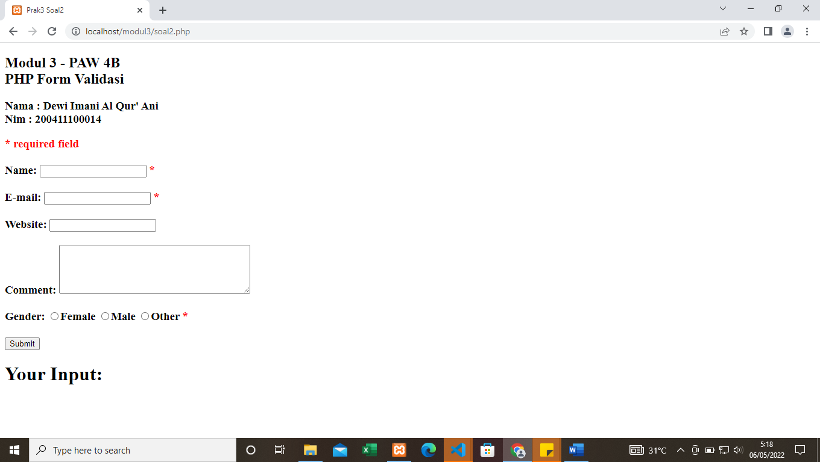

1. Soal : Berikan validasi terhadap kesalahan input pada name, e-mail dan website, seperti  contoh berikut:

**Source Code:**

|  |
| --- |
| <!DOCTYPE html>  <html lang="en">  <head>    <meta charset="UTF-8">    <meta http-equiv="X-UA-Compatible" content="IE=edge">    <meta name="viewport" content="width=device-width, initial-scale=1.0">    <title>Prak3 Soal3</title>  </head>  <body>  <?php    // membuat variabel error dan diset kosong    $nameErr = $emailErr = $genderErr = $websiteErr = "";    //membuat variabel untuk menampung inputan dari form    $name = $email = $gender = $comment = $website = "";    if ($_SERVER["REQUEST_METHOD"] == "POST") {    if (empty($_POST["name"])) {     $nameErr = "Name is required";    } else {      $name = test_input($_POST["name"]);      if (!preg_match("/^[a-zA-Z ]*$/",$name)) {      $nameErr = "Only letters and white space allowed";      }     $name = test_input($_POST["name"]);    }    if (empty($_POST["email"])) {     $emailErr = "Email is required";    } else {      $email = test_input($_POST["email"]);      if (!filter_var($email, FILTER_VALIDATE_EMAIL)) {      $emailErr = "Invalid email format";      }     $email = test_input($_POST["email"]);    }    if (empty($_POST["website"])) {     $website = "";    } else {      $website = test_input($_POST["website"]);      if (!preg_match("/\b(?:(?:https?|ftp):\/\/|www\.)[-a-z0-9+&@#\/%?=_|!:,.;]*[-a-z0-9+&@#\/%=_|]/i",$website)) {        $websiteErr = "Invalid URL";      }     $website = test_input($_POST["website"]);    }    if (empty($_POST["comment"])) {     $comment = "";    } else {     $comment = test_input($_POST["comment"]);    }    if (empty($_POST["gender"])) {     $genderErr = "Gender is required";    } else {     $gender = test_input($_POST["gender"]);    }    }    //membuat fungsi untuk validasi input form    function test_input($data) {     $data = trim($data);     $data = stripslashes($data);     $data = htmlspecialchars($data);     return $data;    }    ?>  <h2>Modul 3 - PAW 4B <br><?php echo "PHP Form Validasi";?><h3>  <h3>Nama : <?php echo "Dewi Imani Al Qur' Ani";?><br>Nim : 200411100014<h3>  <form method="post" action="<?php echo htmlspecialchars($_SERVER["PHP_SELF"]);?>">      <span class="error" style="color:red">* required field</span>      <br><br>      <label for="">Name: </label>      <input type="text" name="name">      <span class="error" style="color:red">* <?php echo $nameErr;?></span>      <br><br>      <label for="">E-mail: </label>      <input type="text" name="email">      <span class="error" style="color:red">* <?php echo $emailErr;?></span>      <br><br>      <label for="">Website: </label>      <input type="text" name="website">      <span class="error" style="color:red"><?php echo $websiteErr;?></span>      <br><br>      <label for="">Comment: </label>      <textarea name="comment" rows="5" cols="40"></textarea>      <br><br>      <label for="">Gender: </label>      <input type="radio" name="gender" value="female">Female      <input type="radio" name="gender" value="male">Male      <input type="radio" name="gender" value="other">Other      <span class="error" style="color:red">* <?php echo $genderErr;?></span>      <br><br>      <input type="submit" name="submit" value="Submit">  </form>  <?php    //menampilkan hasil dari inputan form    echo "<h1>Your Input:</h1>";    echo $name;    echo "<br>";    echo $email;    echo "<br>";    echo $website;    //echo "<br>";    //echo $comment;    //echo "<br>";    //echo $gender;    ?>  </body>  </html> |

**Screenshoot:**

1. 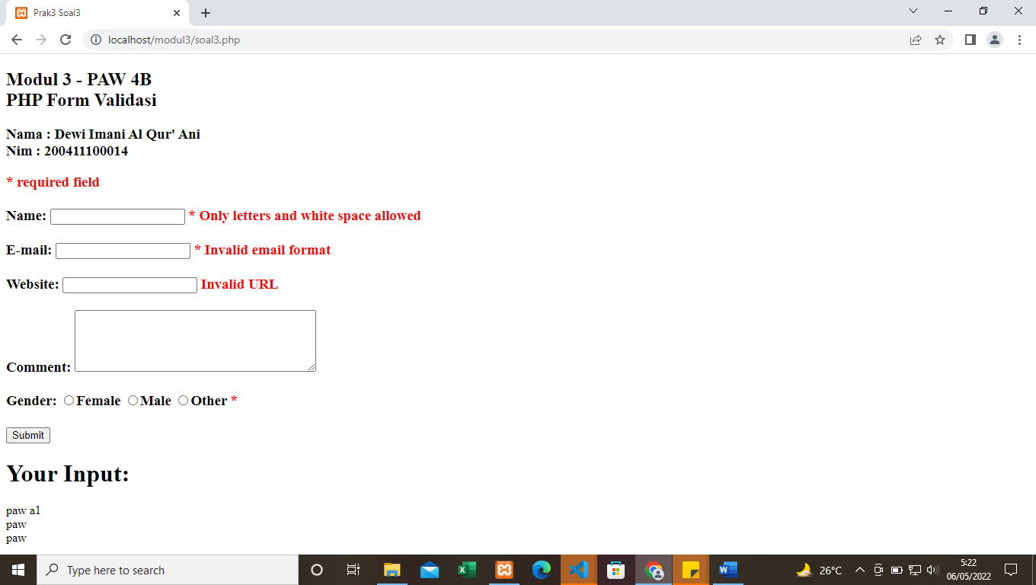Soal : Berikan kondisi pada form apabila dilakukan submit maka value yang diinputkan  pada field tidak hilang

**Source Code:**

|  |
| --- |
| <!DOCTYPE html>  <html lang="en">  <head>    <meta charset="UTF-8">    <meta http-equiv="X-UA-Compatible" content="IE=edge">    <meta name="viewport" content="width=device-width, initial-scale=1.0">    <title>Prak3 soal4</title>  </head>  <body>  <?php    // membuat variabel error dan diset kosong    $nameErr = $emailErr = $genderErr = $websiteErr = "";    //membuat variabel untuk menampung inputan dari form    $name = $email = $gender = $comment = $website = "";    if ($_SERVER["REQUEST_METHOD"] == "POST") {    if (empty($_POST["name"])) {     $nameErr = "Name is required";    } else {      $name = test_input($_POST["name"]);      if (!preg_match("/^[a-zA-Z ]*$/",$name)) {      $nameErr = "Only letters and white space allowed";      }     $name = test_input($_POST["name"]);    }    if (empty($_POST["email"])) {     $emailErr = "Email is required";    } else {      $email = test_input($_POST["email"]);      if (!filter_var($email, FILTER_VALIDATE_EMAIL)) {      $emailErr = "Invalid email format";      }     $email = test_input($_POST["email"]);    }    if (empty($_POST["website"])) {     $website = "";    } else {      $website = test_input($_POST["website"]);      if (!preg_match("/\b(?:(?:https?|ftp):\/\/|www\.)[-a-z0-9+&@#\/%?=_|!:,.;]*[-a-z0-9+&@#\/%=_|]/i",$website)) {        $websiteErr = "Invalid URL";      }     $website = test_input($_POST["website"]);    }    if (empty($_POST["comment"])) {     $comment = "";    } else {     $comment = test_input($_POST["comment"]);    }    if (empty($_POST["gender"])) {     $genderErr = "Gender is required";    } else {     $gender = test_input($_POST["gender"]);    }    }    //membuat fungsi untuk validasi input form    function test_input($data) {     $data = trim($data);     $data = stripslashes($data);     $data = htmlspecialchars($data);     return $data;    }    ?>    <h2>Modul 3 - PAW 4B <br><?php echo "PHP Form Validasi";?><h3>    <h3>Nama : <?php echo "Dewi Imani Al Qur' Ani";?><br>Nim : 200411100014<h3>  <form method="post" action="<?php echo htmlspecialchars($_SERVER["PHP_SELF"]);?>">      <span class="error" style="color:red">* required field</span>      <br><br>      <label for="">Name: </label>      <input type="text" name="name" value="<?php echo $name;?>">      <span class="error" style="color:red">* <?php echo $nameErr;?></span>      <br><br>      <label for="">E-mail: </label>      <input type="text" name="email" value="<?php echo $email;?>">      <span class="error" style="color:red">* <?php echo $emailErr;?></span>      <br><br>      <label for="">Website: </label>      <input type="text" name="website" value="<?php echo $website;?>">      <span class="error" style="color:red"><?php echo $websiteErr;?></span>      <br><br>      <label for="">Comment: </label>      <textarea name="comment" rows="5" cols="40"><?php echo $comment;?></textarea>      <br><br>      <label for="">Gender: </label>      <input type="radio" name="gender" <?php if (isset($gender) && $gender=="female") echo "checked";?>          value="female">Female      <input type="radio" name="gender" <?php if (isset($gender) && $gender=="male") echo "checked";?> value="male">Male      <input type="radio" name="gender" <?php if (isset($gender) && $gender=="other") echo "checked";?>          value="other">Other      <span class="error" style="color:red">* <?php echo $genderErr;?></span>      <br><br>      <input type="submit" name="submit" value="Submit">  </form>  <?php    //menampilkan hasil dari inputan form    echo "<h1>Your Input:</h1>";    echo $name;    echo "<br>";    echo $email;    echo "<br>";    echo $website;    echo "<br>";    echo $comment;    echo "<br>";    echo $gender;    ?>  </body>  </html> |

**Screenshoot:**

